How to Run an Application in AWS
Table of Contents
How to Run an Application in AWS 1
Case Study 1
1: Containerize your application 1
Definition: Container 1
Install Docker Desktop 1
Dependency Management: requirements.txt 2
Dockerfile Configuration 2
Build Docker Image and Test Container Locally 2
2: AWS Account Setup 3
3: Install AWS CLI 3
4: Create a Repository in ECR 4
5: Elastic Container Service : Express Mode 8
Open ECS Express Mode 8
Browse ECR Images - Enter the image URI 8

Case Study
Run a simple Python game that uses Streamlit. (Streamlit is an open-source Python library used to build and share interactive web applications.)
GitHub source code: https://github.com/kathleen-kershaw/Mastermind

1: Containerize your application

Definition: Container
A container is a lightweight, standalone, and executable software package that includes everything needed to run an application—including the code, runtime, system tools, libraries, and settings.
Containers isolate software from its surrounding environment, ensuring that it runs reliably and identically regardless of whether it is being tested locally, deployed on a virtual machine, or pushed to a cloud registry like Amazon ECR. They achieve this by sharing the host operating system's kernel rather than spinning up a full, dedicated operating system for every instance, making them significantly faster and more resource-efficient than traditional virtual machines.

Install Docker Desktop
Docker Desktop is a graphical application that allows developers to build, share, and run containerized applications locally.
- If installing from the Docker website, select the WSL 2 option for the virtualization backend. WSL 2 (Windows Subsystem for Linux 2) provides the underlying system architecture required to run Linux-based Docker containers on a Windows OS.
- If experimenting/learning, you can create a free Personal account. The screenshots in this document are from the free account.

Dependency Management: requirements.txt
Create a file called requirements.txt that lists required libraries. In this example, the file contains the single word “streamlit”.
A requirements.txt file is a plain text file used in Python projects to list all external package dependencies, enabling reliable and reproducible installations via pip install -r requirements.txt. It is not specific to containerization, but it is used by the container build process.

Dockerfile Configuration
Write a Dockerfile specifying a lightweight Python base image, setting up the working directory in the container, copying the source files, installing requirements, and exposing port 8501 for Streamlit.
Port 8501 is the official standard default port chosen by Streamlit for running local web applications. Streamlit automatically binds to port 8501 when you run streamlit run.

Build Docker Image and Test Container Locally
In the terminal window, type
docker build -t mastermind-web .
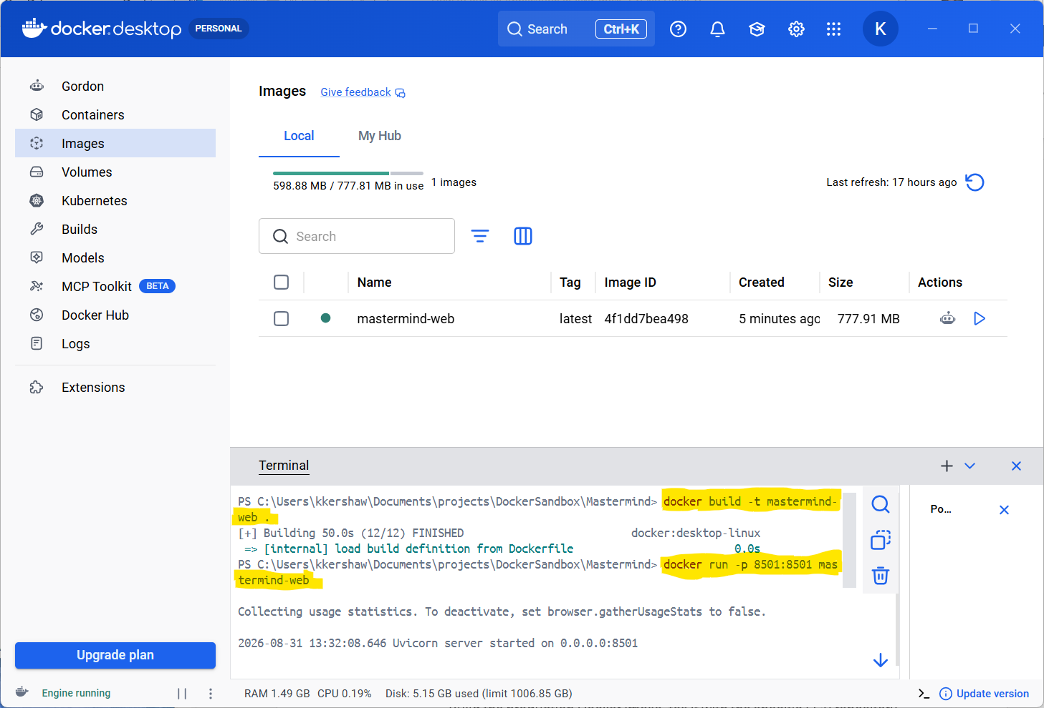

docker run -p 8501:8501 mastermind-web
To view the app, open in a browser: http://localhost:8501

2: AWS Account Setup
- Go to the AWS Management Console (https://aws.amazon.com)
- Click Create an AWS Account in the top right.
- Follow the prompts to enter your email, choose a password, and provide your contact information.
- Payment Information: AWS requires a credit card for verification purposes and to prevent fraud. There is a free tier and a low-cost tier for low-traffic personal projects.
- Identity Verification: They will ask to verify your phone number via a quick text.

3: Install AWS CLI
The recommended install script lives here:
Installing or updating to the latest version of the AWS CLI - AWS Command Line Interface
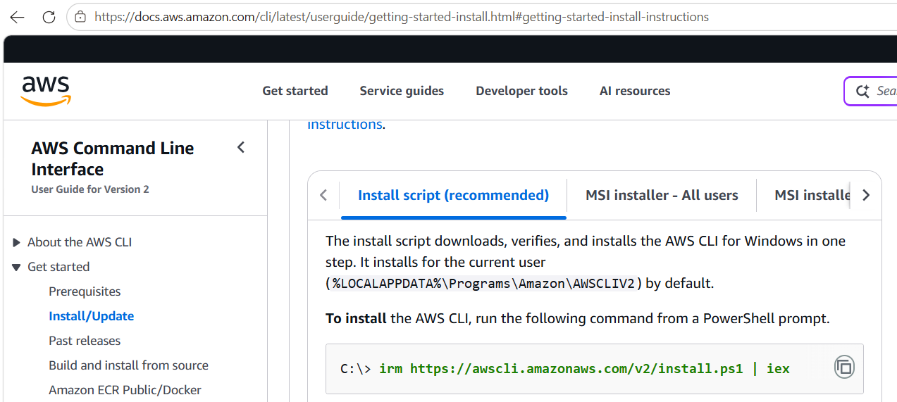

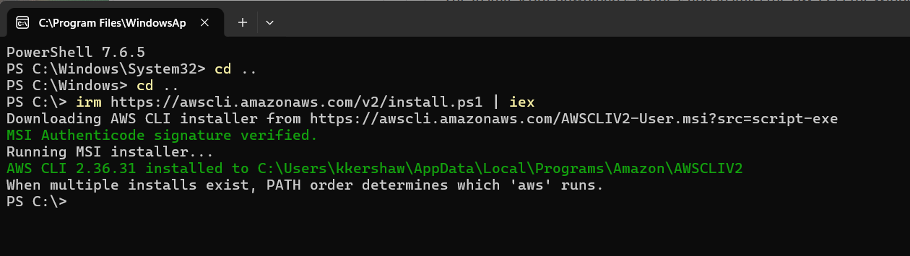

4: Create a Repository in ECR
- ECR (Elastic Container Registry) Repository Creation: Create a private Amazon ECR repository to store version-controlled container images. Note: this is a “storage locker”, not the running website
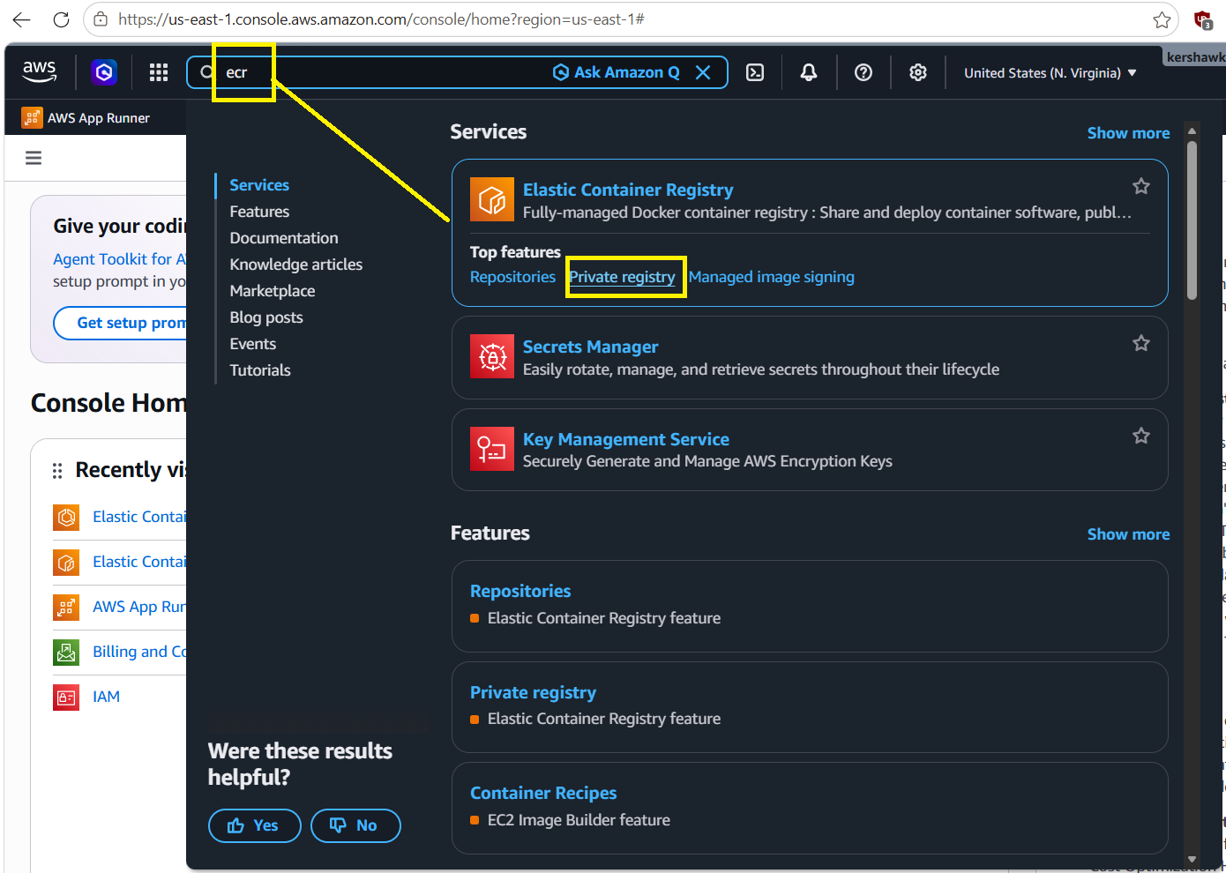
  - Note: AWS App Runner comes up in AI instructions for setup. However, App Runner is not accepting new customers as of 4/2026, so use ECR

In the ECR console, click the orange Create repository button.
- Fill in the repository name
- Leave the other items default
- Click the orange Create button at the bottom
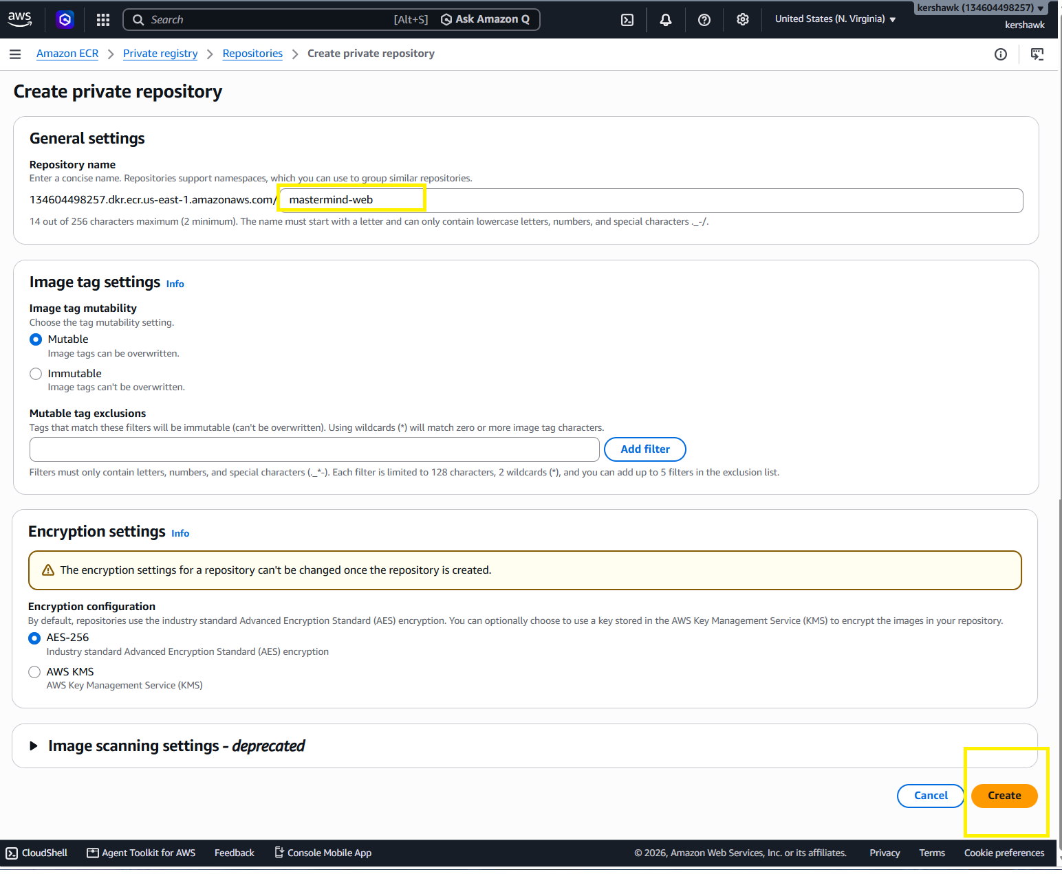

Click to View the Push Commands
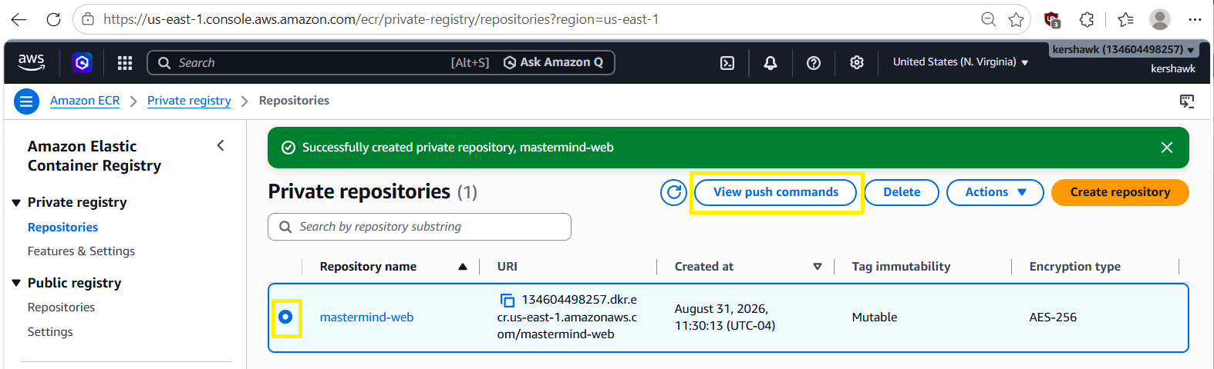

Copy-and-Paste the Push Commands as specified below

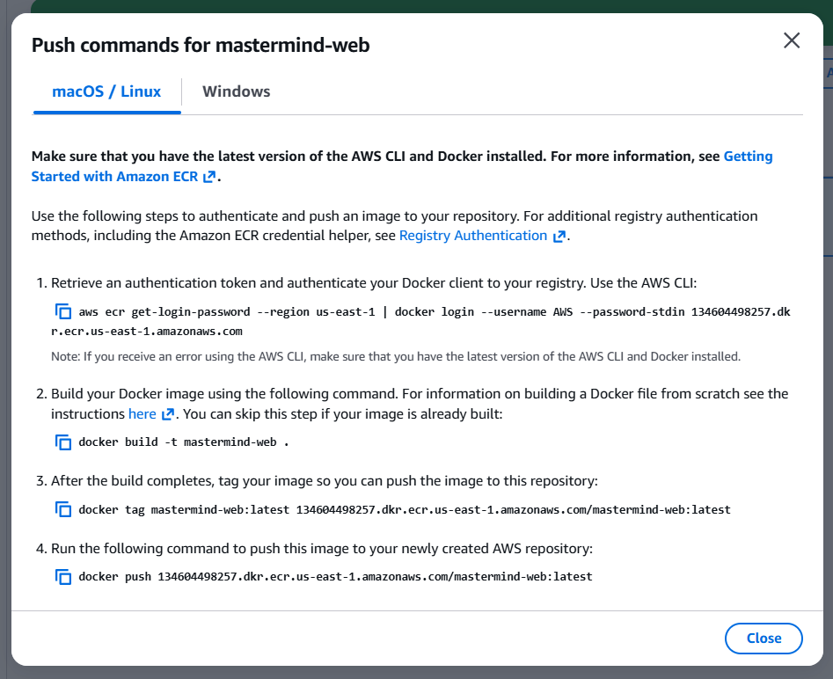

Authenticate the local Docker client to the AWS ECR registry using the AWS CLI.
aws ecr get-login-password --region us-east-1 | docker login --username AWS --password-stdin 134604498257.dkr.ecr.us-east-1.amazonaws.com
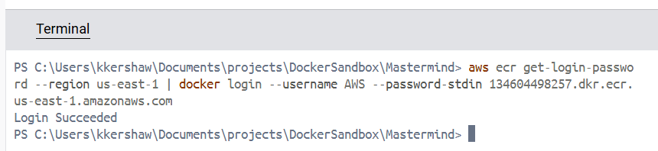

Build the production Docker image, tag it with the specific ECR repository URI, and execute a Docker push to upload the container image to Amazon ECR, making it ready for deployment.
docker tag mastermind-web:latest 134604498257.dkr.ecr.us-east-1.amazonaws.com/mastermind-web:latest
docker push 134604498257.dkr.ecr.us-east-1.amazonaws.com/mastermind-web:latest

5: Elastic Container Service : Express Mode

Open ECS Express Mode
- Type ECS in the AWS website search bar
- Click on Elastic Container Service, then Express Mode.
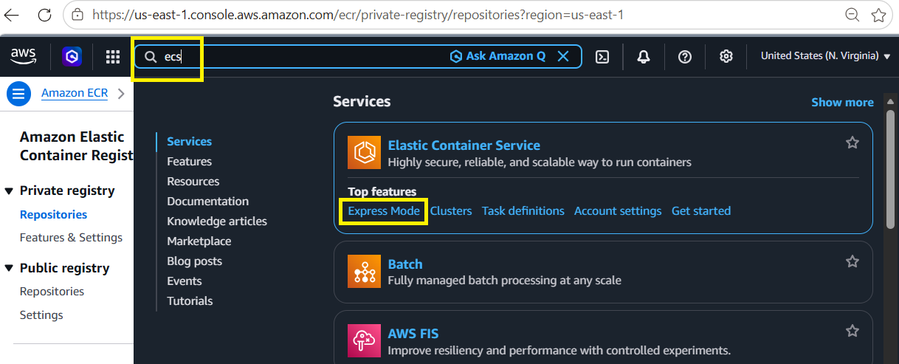

Browse ECR Images - Enter the image URI

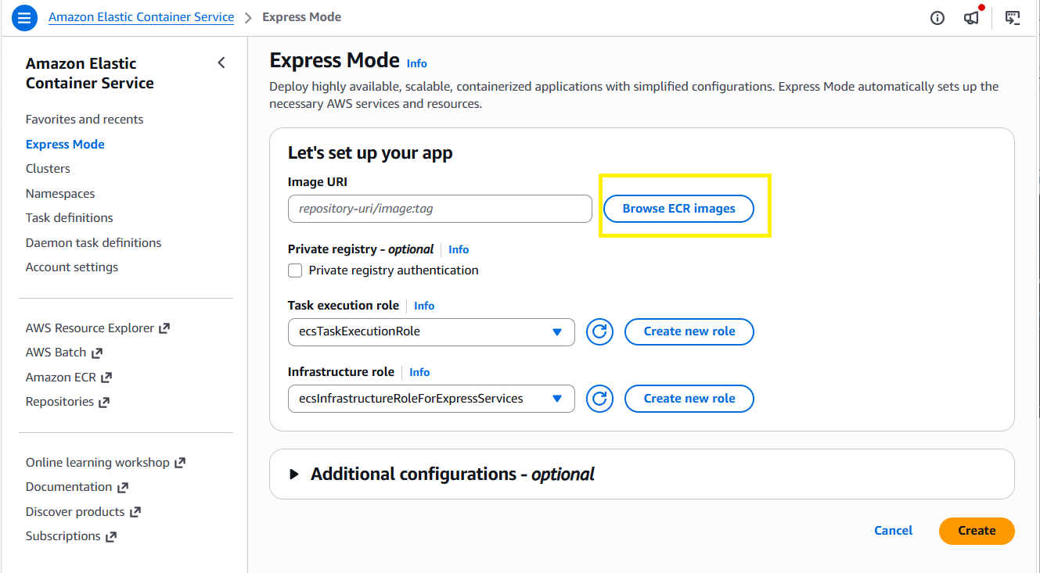

Select the image from the dropdown, then Click the button Select Image

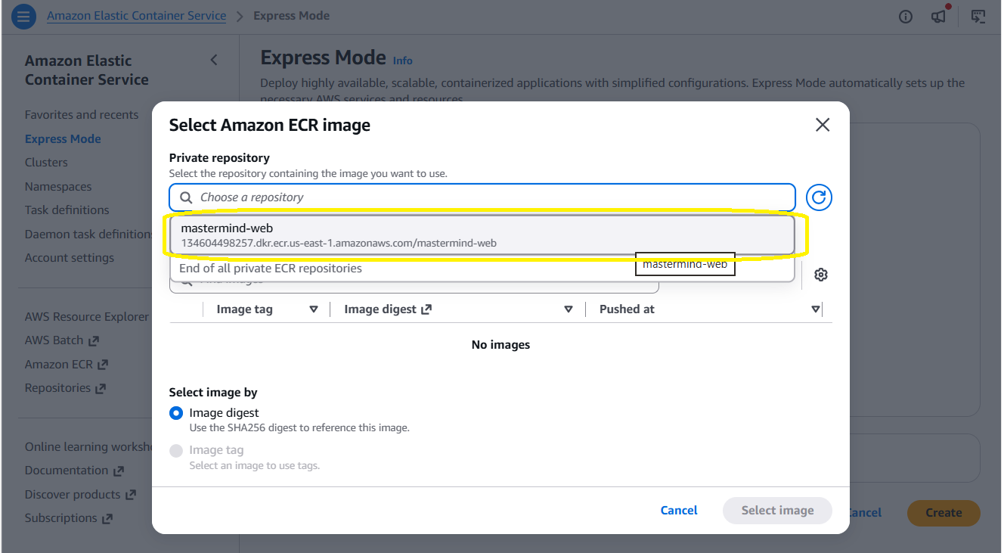

Click Create
